**Name:** V Venkata Sri Prasad

**Batch:** Data Engineering

**Date:** 22/02/2024 – (Day 25)

Topics:

1. Introduction to Devops
2. Creating Devops project

**Azure DevOPS:**

Azure DevOps is a comprehensive set of development tools provided by Microsoft to support software development projects. It includes several services, each serving a specific purpose in the software development lifecycle. Here's an explanation of Azure Boards, Azure Repos, Azure Pipelines, Azure Test Plans, and Azure Artifacts:

1. **Azure Boards:** Azure Boards is a flexible project management tool for planning, tracking, and discussing work across teams. It provides agile tools for planning and tracking work, including backlogs, Kanban boards, sprint planning, and customizable dashboards. Teams can use Azure Boards to manage their work using Agile, Scrum, or other methodologies, enabling them to plan and track their work effectively.
2. **Azure Repos:** Azure Repos provides Git repositories or Team Foundation Version Control (TFVC) for source control of your code. It supports both centralized and distributed version control workflows. With Git repositories, developers can collaborate on code, manage branches, perform code reviews, and integrate with Azure Pipelines for automated builds and deployments. Azure Repos offers unlimited private Git repositories and scales to support large teams and projects.
3. **Azure Pipelines:** Azure Pipelines is a cloud-based continuous integration and continuous delivery (CI/CD) service that automates the build, test, and deployment of your code. It supports building and deploying applications for any platform, including Windows, Linux, macOS, and various programming languages and frameworks. Azure Pipelines allows you to define pipelines using YAML or the visual designer, which can include tasks such as compiling code, running tests, packaging artifacts, and deploying applications to various environments. It integrates with Azure Repos, GitHub, Bitbucket, and other source control repositories.
4. **Azure Test Plans:** Azure Test Plans is a testing solution that provides a set of tools for manual and exploratory testing of applications. It allows teams to create test plans, test suites, and test cases, manage test environments, and execute tests across different configurations. Teams can also track test results, file bugs, and collaborate on testing activities. Azure Test Plans integrates with Azure Boards, Azure Repos, and Azure Pipelines, providing end-to-end traceability from requirements to test execution.
5. **Azure Artifacts:** Azure Artifacts is a package management service that allows teams to create, host, and share packages such as NuGet, npm, Maven, and Python packages. It provides a centralized repository for managing dependencies and artifacts used in software development projects. With Azure Artifacts, teams can publish and consume packages within their organization securely. It integrates with Azure Pipelines and other CI/CD systems, enabling automated package management and deployment workflows.

Creating Devops project:

Go to Azure DevOps organizations:

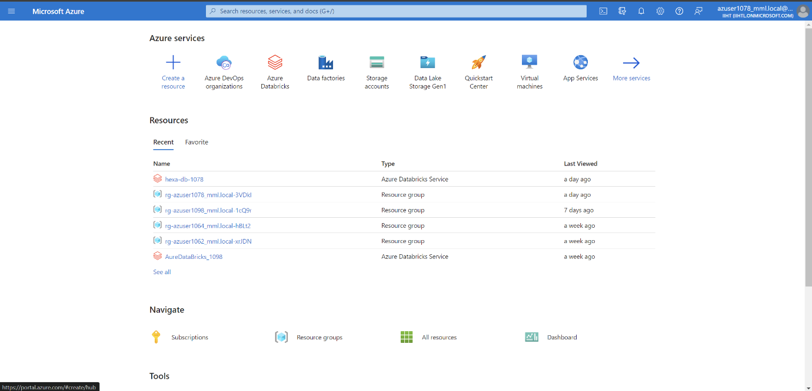

Go to My Azure DevOps Organizations

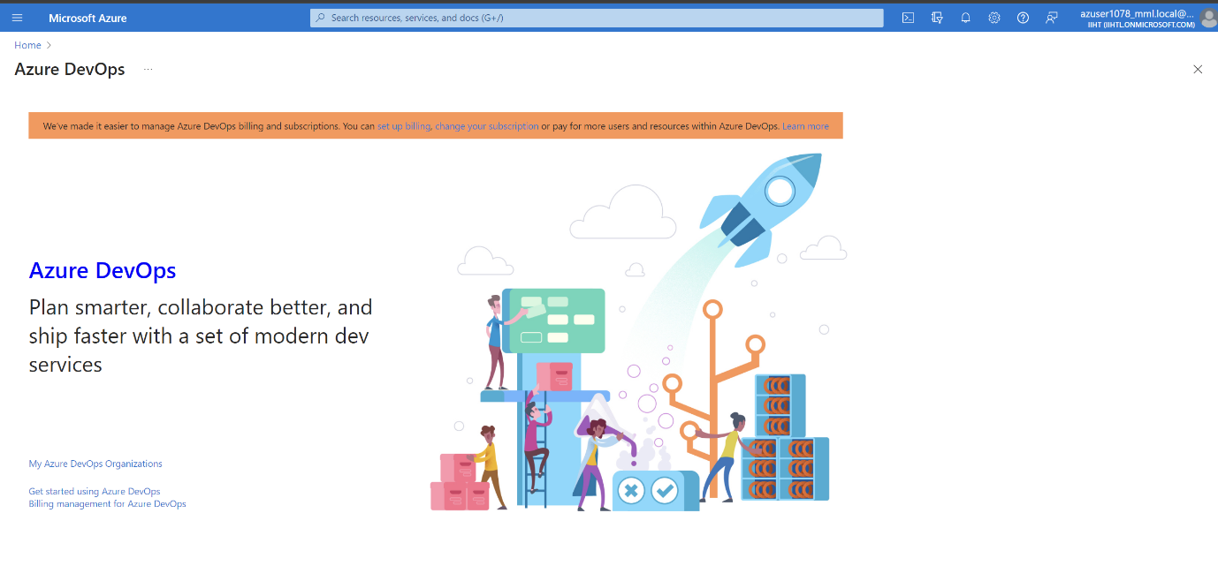

Give your name and click on continue

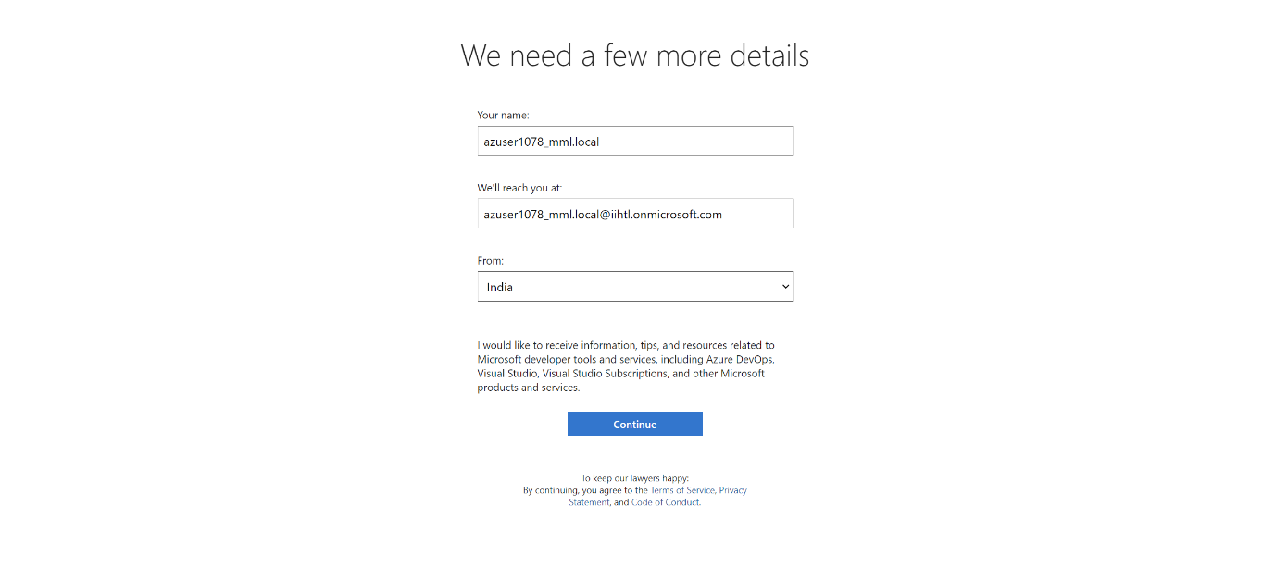

Give project name and keep it as private

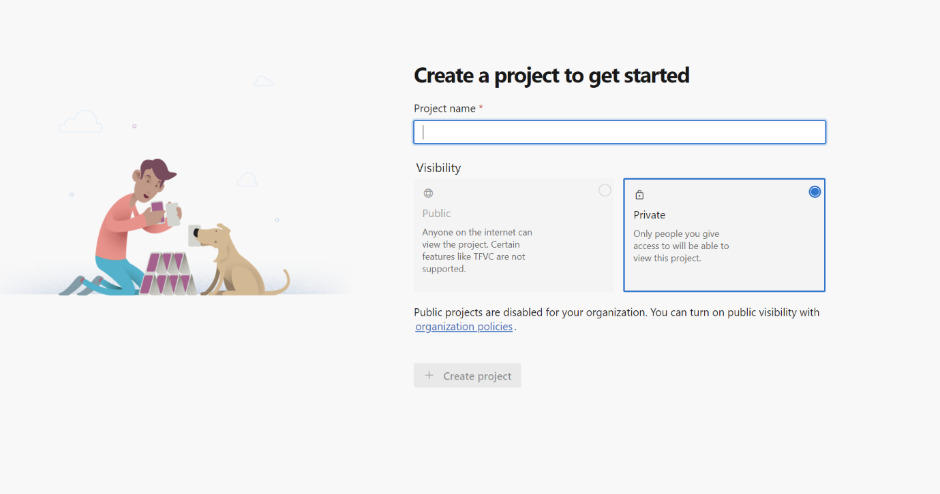

Go to Create new Organisation:

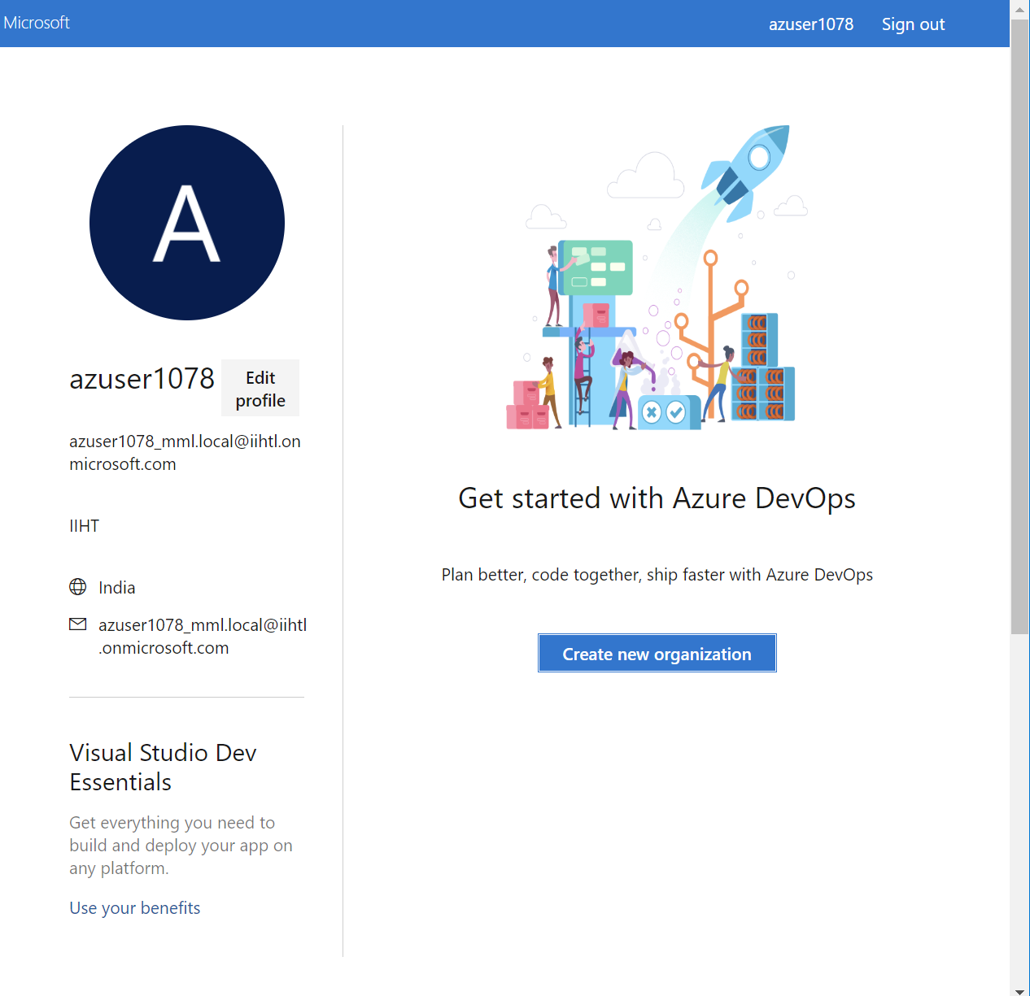

Go to boards and click on work iten and select new work item and choose epic or issue or task

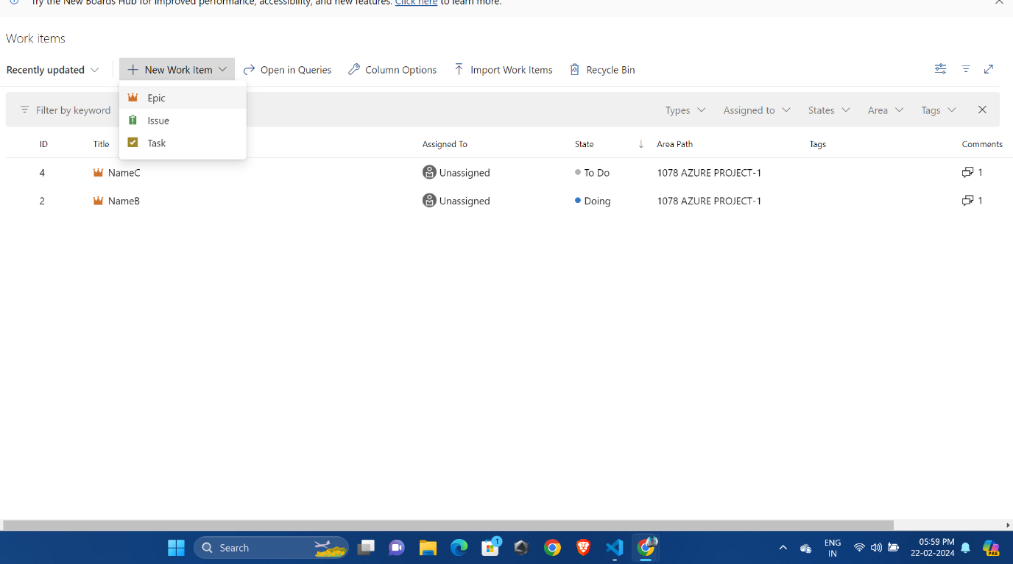

Enter title , description, discussion, status as doing

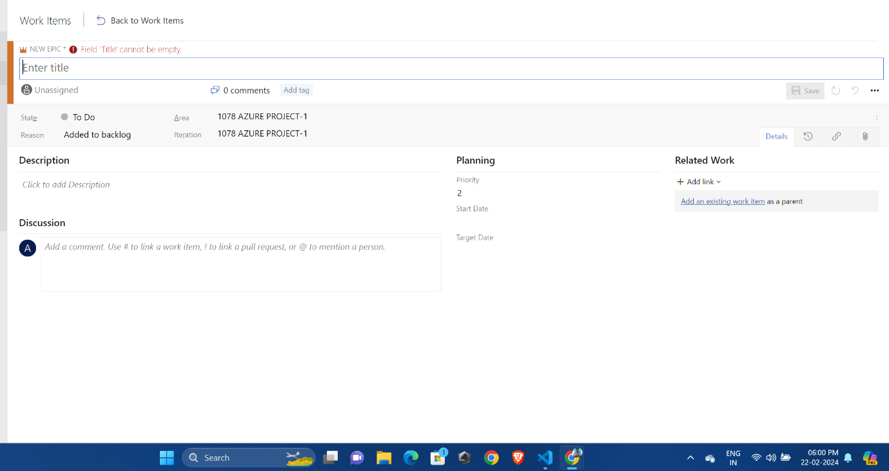

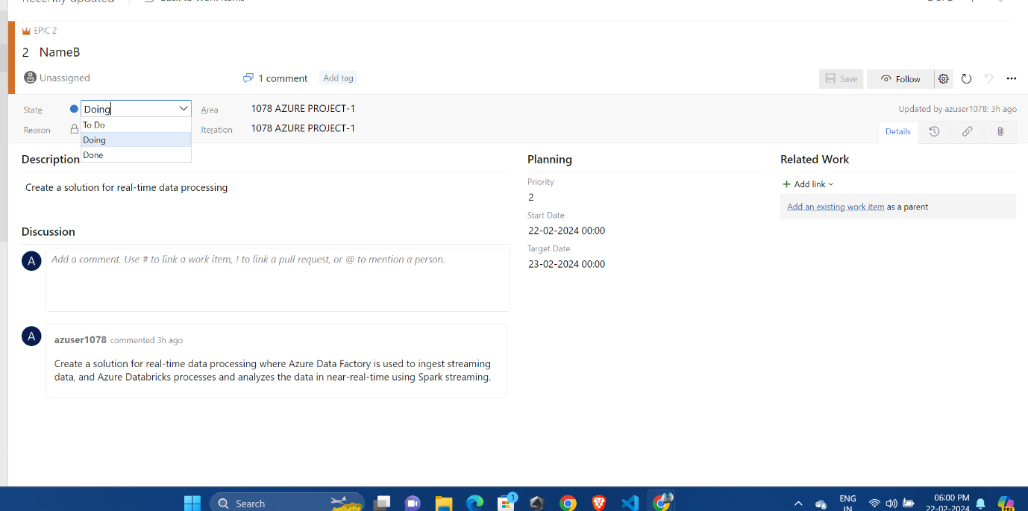

In boards we can create boards to represent Items

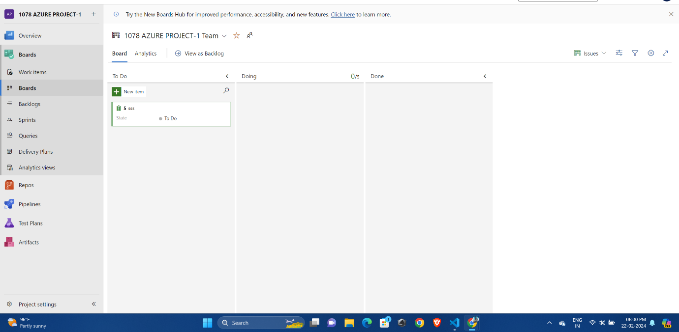

Queries section we can execute the queries and here we are executing tasks which are in doing state

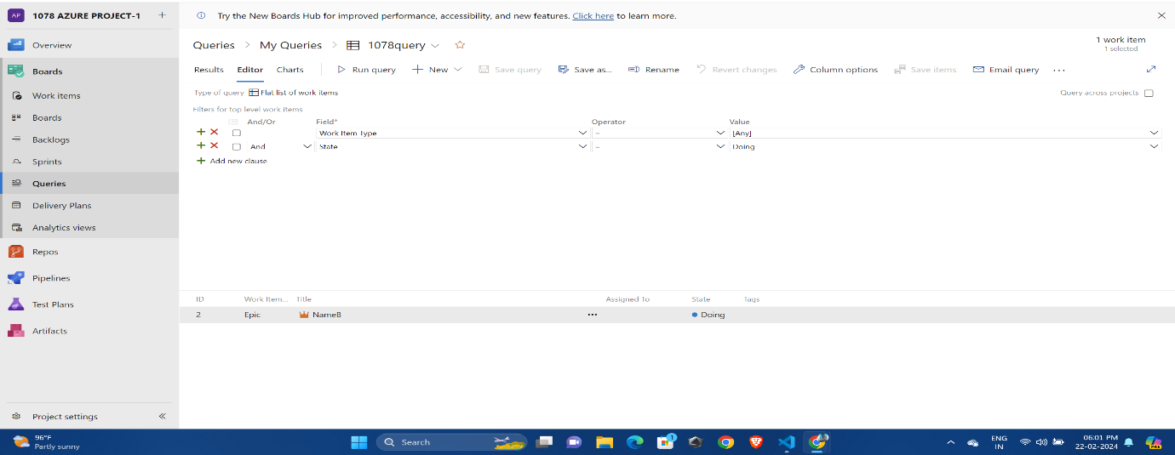

Notes:

